Using GitHub Classroom at KVCC

# Background

Moodle doesn’t provide a good way for students to submit programming homework. Students either have to zip up their solutions and submit the zip file or submit a bunch of files for their assignment.

It can also be frustrating to them when they have several versions of an assignment and end up creating a different directory for each version. Also, they may make an update that breaks what they already had working and it isn’t easy to revert back to an earlier version.

If you have groups of students working together on a project things can get even more confusing trying to keep everybody in synch.

A software version control program like **git** can help!

Review <https://github.com/KVCC-Java/course-info/blob/master/course-setup.md> for an overview of how working with GitHub will work for your students.

GitHub has two types of accounts: [personal user accounts and organization accounts](https://help.github.com/articles/what-s-the-difference-between-user-and-organization-accounts). To get started, you and each student/co-teacher will need to [create a personal account](https://help.github.com/articles/signing-up-for-a-new-github-account), if you or they don't have one already. Each individual user on GitHub should have exactly one personal account. There's no need to maintain a separate account just for teaching, we'll use an organization for that.

# Step 1: Get a classroom setup

Visit <https://education.github.com/> which is the GitHub Education portal. The first thing you will want to do is request a discount for an organization account.

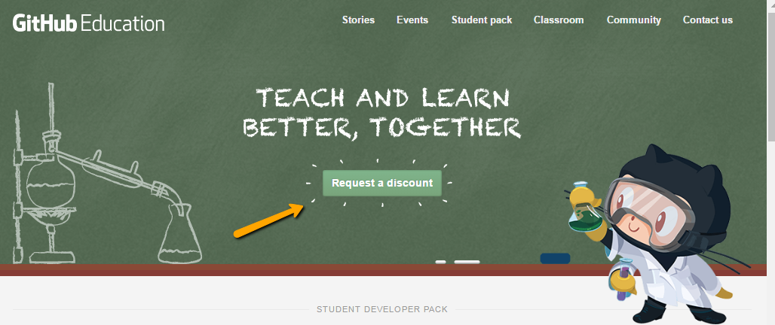

Request enough private repositories: Each student will use 1 repository for each assignment. So if you have 11 students and 12 assignments you will need 132 private repositories. Once you have requested an organization account for your classroom you will receive an email. Typically they will now grant unlimited private repositories for educational organizations.

Next go to <https://classroom.github.com/classrooms> and click on the “New Classroom” button. Select the organization for your classroom and set it up. If you have a co-teacher you can add them as an administrator to the classroom.

# Step 2: Add an assignment

Create a repository with a readme.md file that explains the assignment along with any starter code you want to provide.

Next back at your GitHub Classroom <https://classroom.github.com/classrooms> click on “New assignment”. Select if you want the assignment to be an individual or group assignment and fill out the settings for the assignment. Under the “Add your starter code from GitHub” entry, specify the repository for the assignment that you created earlier in this step. Then create the assignment by clicking on the button.

# Step 3: Publish the assignment in Moodle

After you have created the assignment in GitHub classroom it provides you with a URL to share with the students. Publish this URL in Moodle as a URL item.

When the student clicks on the URL they will be taken to the GitHub classroom so they can get setup as a member of the organization and accept the assignment.

After accepting the assignment a repository will be created for them with the assignment readme.md file and any starter files you provided.

# Step 4: Students work and complete on the assignment

Using the directions in <https://github.com/KVCC-Java/course-info/blob/master/course-setup.md> the students will be able to create local copies of the repository created in step 3 and work on the assignment.

When they are done they will submit the assignment as instructed in the document.

# Step 5: Grade the assignment

Since the instructor is an administrator of the classroom organization they can clone each student’s private repository to get access to the code. Any feedback they want to provide can be done by creating issues in GitHub.

I have created windows batch and bash script files that will clone each student’s work.

Grade the assignment and post the grade in Moodle.